附件四

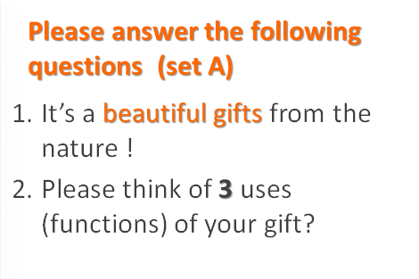**SET A 問題**

1. It’s a beautiful gift from the nature!
2. Please think of **3** uses (functions) of your gift?

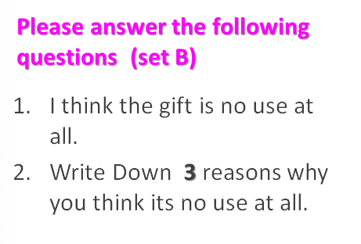**SET B 問題**

1. I think the gift is no use at all.
2. Write Down **3** reasons why you think it is no use at all.