### Annex 8 Activity K: Worksheet for Career Exploration – Fashion Designer

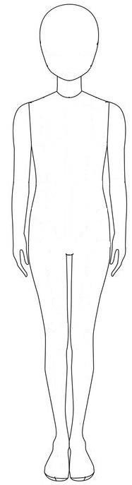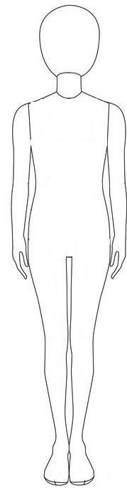**Task: Fashion Design – Teen**

|  |  |  |  |  |  |  |
| --- | --- | --- | --- | --- | --- | --- |
| **School:** |  | **Class:** |  | **Class No.:** |  | **Name:** |
| **FRONT** | | | **BACK** | | | |
| **SIDE**  **SIDE** | | | | | | |

**Task: Fashion Design – Man**

|  |  |  |  |  |  |  |
| --- | --- | --- | --- | --- | --- | --- |
| **School:** |  | **Class:** |  | **Class No.:** |  | **Name:** |
| **FRONT** | | | **BACK** | | | |

**SIDE**

**Task: Fashion Design – Woman 1**

|  |  |  |  |  |  |  |
| --- | --- | --- | --- | --- | --- | --- |
| **School:** |  | **Class:** |  | **Class No.:** |  | **Name:** |
| **FRONT** | | | **BACK** | | | |
| **SIDE** | | | | | | |

**Task: Fashion Design –Woman 2**

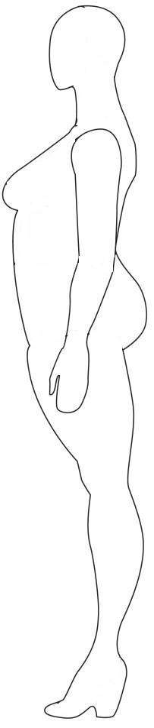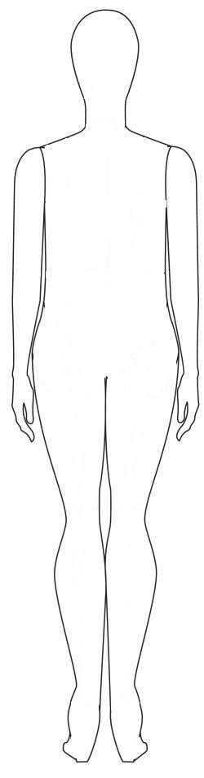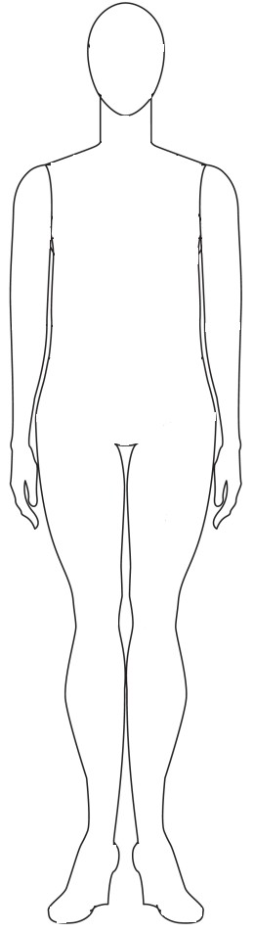

|  |  |  |  |  |  |  |  |  |  |
| --- | --- | --- | --- | --- | --- | --- | --- | --- | --- |
| **School:** | | **Class:** | | **Class No.:** | | | | **Name:** | |
|  |  | |  | |  |  |  | |  | |
| **FRONT** | | | | | **BACK** | | | | | |

**SIDE**