Annex 6

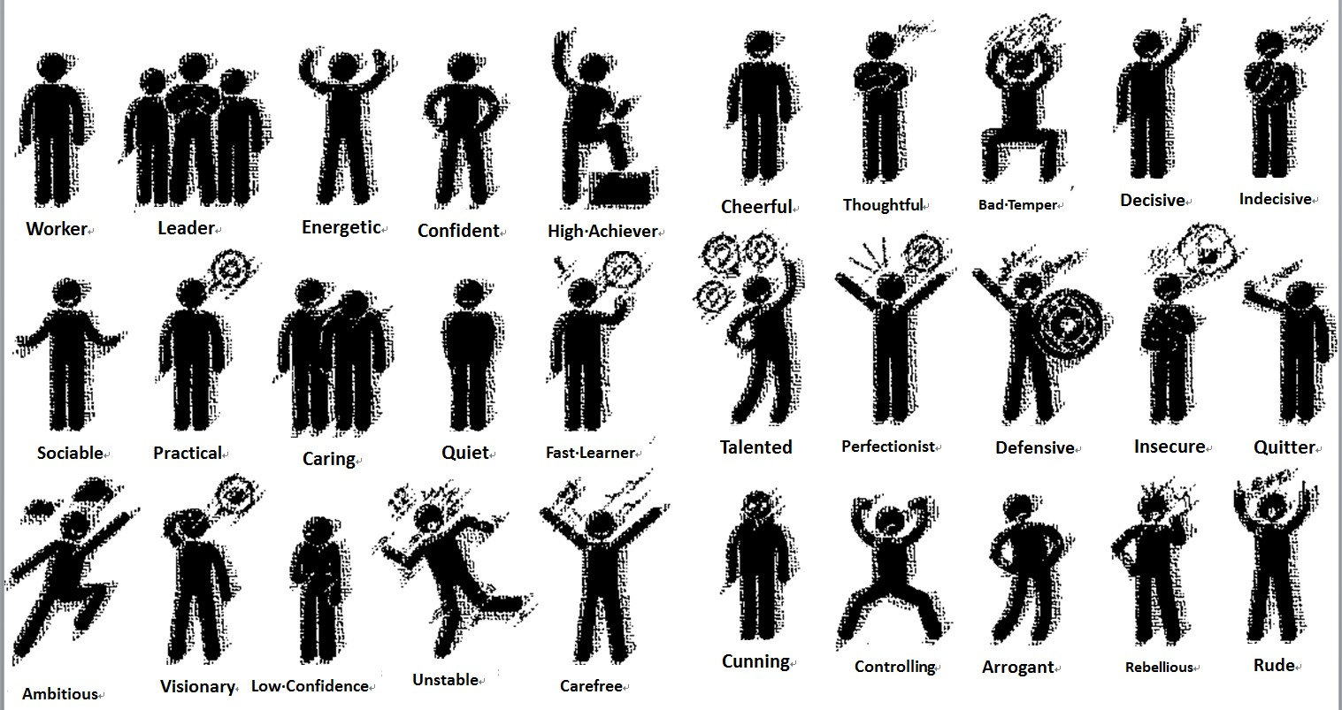



**What is your expectation on your child? Or desired job (1 or 2 is fine)**