Annex 4

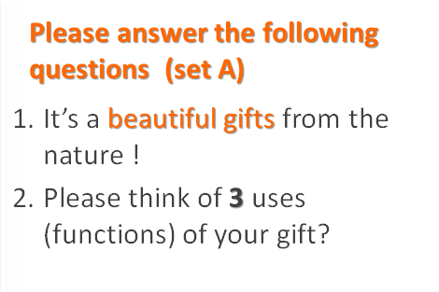SET A

1. It’s a beautiful gift from the nature!
2. Please think of **3** uses (functions) of your gift?

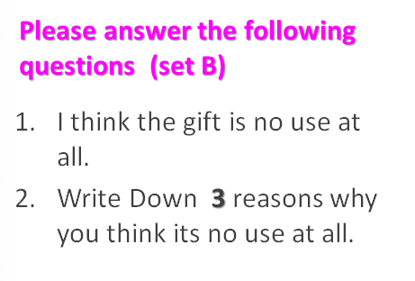SET B

1. I think the gift is no use at all.
2. Write Down **3** reasons why you think it is no use at all.