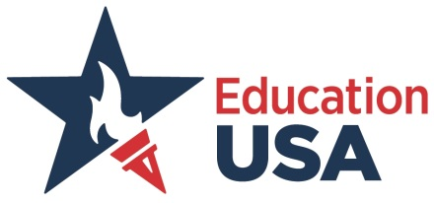

Dear Educator,

EducationUSA is a U.S. Department of State network of over 400 international student advising centers in more than 170 countries. The network promotes U.S. higher education to students around the world by offering accurate, comprehensive, and current information about opportunities to study at accredited postsecondary institutions in the United States. Our office is located at the U.S. Consulate General in Central. We provide an array of services, including free one-on-one advising services for students interested in applying to U.S. colleges/universities and seminars for students/parents/ educators on higher education opportunities in the U.S. You are cordially invited to our upcoming seminar:

**The Community College and Alternative Pathways to Success**

**June 14, 2017 (Wednesday)**

**5:30 PM – 6:30 PM**

**Holiday Inn Golden Mile (Crystal Room 1, Level B3)**

**50 Nathan Road, Tsim Sha Tsui, Kowloon**

The presenter, Ms. Linda S. Bowman, is President Emerita of the Community College of Aurora and currently serves as Vice President for Executive Leadership Training and Development for the Colorado Community College System. She has spent over 25 years in American community colleges, including 13 as president, as well as adjunct faculty, campus director, dean, vice president, and vice president of the state-wide system. Previously, she worked 12 years in private U.S. colleges, including six as president.

Almost 40% of American high school graduates start their college education at community colleges. Globally, an increasing number of international students attend American community colleges as a stepping stone to prestigious 4-year colleges and universities. What are the benefits of attending a community college and which students are a good fit for this path? The seminar will cover the quality, articulation agreements, and accreditation of community colleges and allow ample time for questions and discussion.

We hope that you will join us. Please register online at <https://goo.gl/HWZCPs>

If you have any questions, please call us at (852) 2841 2525.

Sincerely,

Venice Chan Nina S. Lewis

Senior EducationUSA Advisor Cultural Affairs Officer