# 附件 6 活動 I：HSIC 2.0 「香港標準行業分類 2.0 版」

**「行業分類 2.0」表格**

**Hong Kong Standard Industrial Classification （HSIC） Version 2.0 ― Index of Industry Codes**

**School:**

**Class:**

**Class No.:**

**Name:**

**Please tick** ✓ **5 boxes to select your preference.** • Bank teller

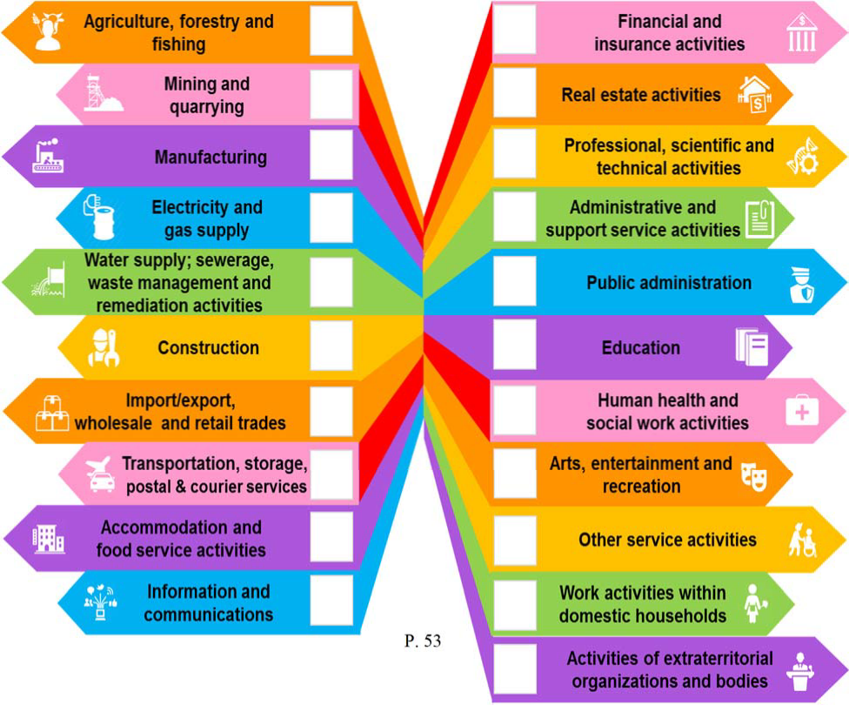

* Forestry Officer
* Farm worker
* Fishery worker
* Mining and quarrying worker
* Shotfirer
* Production worker （E.g. food／ textiles…）
* Butcher／ Carpenter
* Electrical fitter （E.g. Aircraft Maintenance）
* Electrical technician
* Overhead linesperson／ Cable jointer （Power）
* Waterworks inspector
* Plumber／ Pipelayer
* Construction supervisor／ Site agent
* Bricklayer／ Concretor／ Welder
* Painter & decorator／ Plumber／ Bamboo scaffolder
* Merchandiser／ Buyer
* Retail salesperson
* Driver／ Marine crew／ Sailor
* Pilot

P. 53

* Postman／ Courier
* Waiter／ Waitress／ Bartender／ Chef／ Baker
* Hotel receptionist／ Bell superintendent
* Flight purser／ Flight attendant
* Editor／ Disc jockey／ Broadcast assistant
* Director／ Presenter／ Reporter
* Computer game／ Software programmer
  + Insurance consultant／ agent
  + Financial planner
  + Real estate agent
  + Lawyer ／ Accountant ／ Architect ／

Engineer

• Veterinarian／ Designer／ Photographer

* + Translator
  + Travel agent／ Tour consultant

• Investigation detective

* + Function coordinator
  + Police constable／ Firefighter
  + Immigration officer／ Correctional officer
  + Teacher／ Lecturer
  + Sport instructor
  + Music instrument tutor
  + General Practitioner （Doctor）／ Dentist
  + Nurse／ Pharmacist／ Psychologist
  + Social worker／ Counsellor
  + Actor／actress
  + Comic illustrator／ Musician

• Athlete／ Dancer

* + Monk／ Clergy
  + Hairstylist／ Makeup artist／ Pet groomer
  + Councilor／ Legislative Council member
  + Domestic helper
  + Housekeeping assistant
  + Working in extraterritorial organizations and bodies （E.g. World Health Organization／ International Atomic Energy Agency）